

Features & Benefits

Congestion Control offers a comprehensive suite of content optimization capabilities that provide a superior viewing experience at a much lower cost

Dynamically detects congestion and applies optimization only to hotspots

Adjusts Video quality to provide the optimum user experience based on available bandwidth and context

Identifies and caches popular videos and images, speeding up responses
Detects new internet video formats and pushes solution updates over the cloud
Compresses up to 70% of web content
360-degree view of network traffic and usage patterns
Congestion Control

Intelligent Optimization of Web and Video Content

The proliferation of smart mobile devices and popularity of mobile video applications has created both a unique business opportunity and some network challenges for the mobile service provider. Service providers have expanded mobile network capacity to meet subscribers’ growing data needs. However, even with significant capacity expansions, service providers continue to face capacity crunches in specific sectors of the network.

Large numbers of subscribers accessing multimedia content from a particular area can create localized capacity crunches; spectrum availability and backhaul capacity also contribute to the problem. Network hotspots tend to occur in areas such as downtown and business districts that have significant numbers of subscribers. If unaddressed, congestion can significantly degrade the subscriber experience, leading to higher churn and reduced profitability.

Our Solution

Openwave Mobility’s Congestion Control offers a comprehensive suite of web and video optimization capabilities that provide a unique and personalized viewing experience.
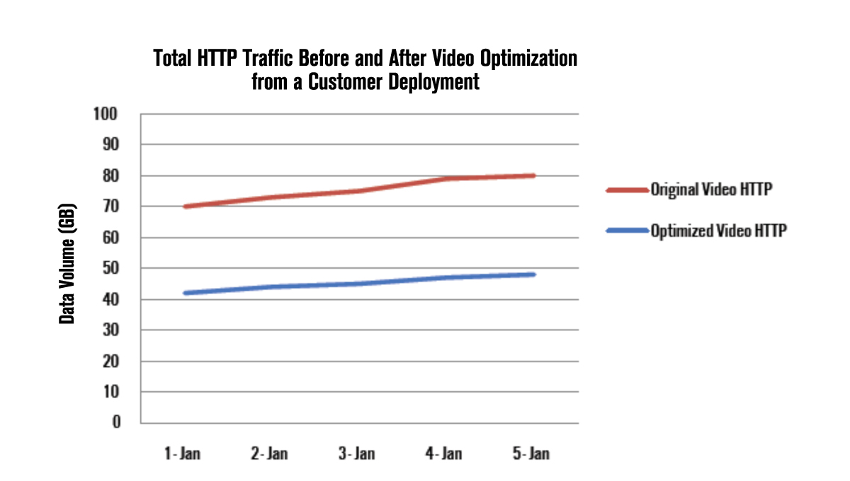

Congestion Control provides a 360-degree view of network traffic and usage patterns, including a view of localized hotspots. It dynamically detects congestion hotspots and applies just the right amount of optimization, exactly when and where required, based on network conditions, device capabilities, content characteristics, service provider policies and customer price plans. Optimizing congestion hotspots only significantly reduces the processing power required, lowering the solution’s hardware footprint and total cost of ownership (TCO).

Congestion Control

Intelligent Optimization of Web and Video Content

Adding Value

Congestion Control frees up network bandwidth, allowing carriers to add new subscribers without compromising quality of experience.

Video Format Update Service

Increased video traffic over the internet has resulted in new video formats and places demands on any optimization solution to respond quickly. Congestion Control constantly monitors for changes in video formats and delivery mechanisms on the internet. Openwave Mobility develops solutions for new formats and containers, and pushes updates over the cloud to customer deployments, minimizing network disruption.
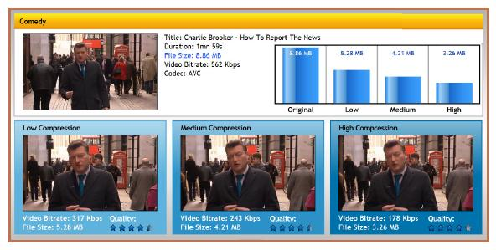

High Quality of Experience

Congestion Control guarantees a high quality experience for subscribers whether viewing web or video content. Playback is smooth even during periods of network congestion, videos are delivered just-in-time, reducing unwatched downloads, and at all times the content is matched to the subscriber’s device capability. A variety of techniques is used for both web and video optimization including caching of popular videos and deployment of latest codecs, and all content types are covered including MP4 optimization.

Delivering Critical Business Insights

Dashboards provide at a glance feedback on the savings achieved by using Congestion Control, subscriber viewing behavior, device usage and content type downloaded. More sophisticated reporting is available by integrating Mobile Analytics, which enables slicing and dicing of data on multiple dimensions, and creation of custom segments to track and report on targeted subscribers.

Find out more

Download the Product Sheets for Web Optimizer / Media Optimizer, or request a solution demo.

About Openwave Mobility

Openwave Mobility empowers operators to manage and monetize mobile data using the industry’s most scalable, Layer7 SDN/NFV enabled platform, Integra.

Integra applies advanced Video Optimization to eliminate data congestion, while using Policy Engagement and Analytics to increase ARPU through personalized data
plans.

Openwave Mobility provides true carrier class solutions, working with over 40 of the world’s largest service providers and delivering over 40 billion transactions every day to over half a billion subscribers.

Openwave Mobility is a global company headquartered in Redwood City, California.

Openwave Mobility and the Openwave Mobility logo are registered trademarks and/or trademarks of Openwave Mobility Inc. in various jurisdictions. All other trademarks are the properties of their respective owners.

Copyright © 2013 Openwave Mobility Inc. All rights reserved.



1600 Seaport Boulevard, 4th Floor
Redwood City
California 94063
U.S.A.
Corporate +1 650 480 7200 http://www.owmobility.com

